Kellie Turchetta

Southern New Hampshire University

CS-330

Final Project Review

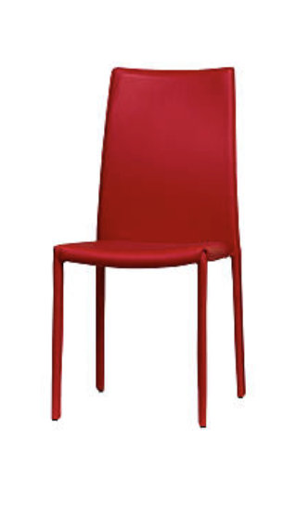

I originally chose a cup for my project but I really struggled when it came to making the handle. So, I decided to search for a different object to work on instead. I wanted to develop an object based on squares instead of circles because I had more experience with them. So, I searched through stock images and found a red chair. The red chair fits the guidelines for the project because it falls under the furniture category. I was able to program for the functionality required by applying what I have learned throughout the course.

I was able to use vertices and indices to create the seat, the back, and the legs of the chair. I used the color red (1.0f, 0.0f, 0.0f) for each section of the chair since the entire thing is the same shade of red. I used lighting and textures to make the chair appear plastic and see-through like it does in the photo. I used the UMouseMove function to allow the user to move the chair horizontally and vertically based on how they navigate their mouse. The function allows the user to move the camera around and view the chair from different angles. I used the letter ‘w’ to move the chair forward, the letter ‘s’ to move the chair backwards, the letter ‘a’ to move my camera left, and ‘d’ to move the chair to the right.

The most important aspects when it came to organizing my code were ensuring proper spacing throughout, accurate spelling/grammar, and detailed comments with explanations. The final project pieced together all of the aspects learned throughout the course. Such as shapes, lighting, texture, camera angles, etc. The functions provided in the code can be re-used to create various other 2D and 3D objects in the future. I am interested in pursuing a job in web design so I had a lot of fun working with graphics throughout this course (especially the final project). This course was extremely challenging for me and I had many obstacles to overcome but the information that I have learned will help me greatly in my future career.